The basic skills that are required

* Os , mostly linux
* Command-line
* Scripting
* Monitoring tools

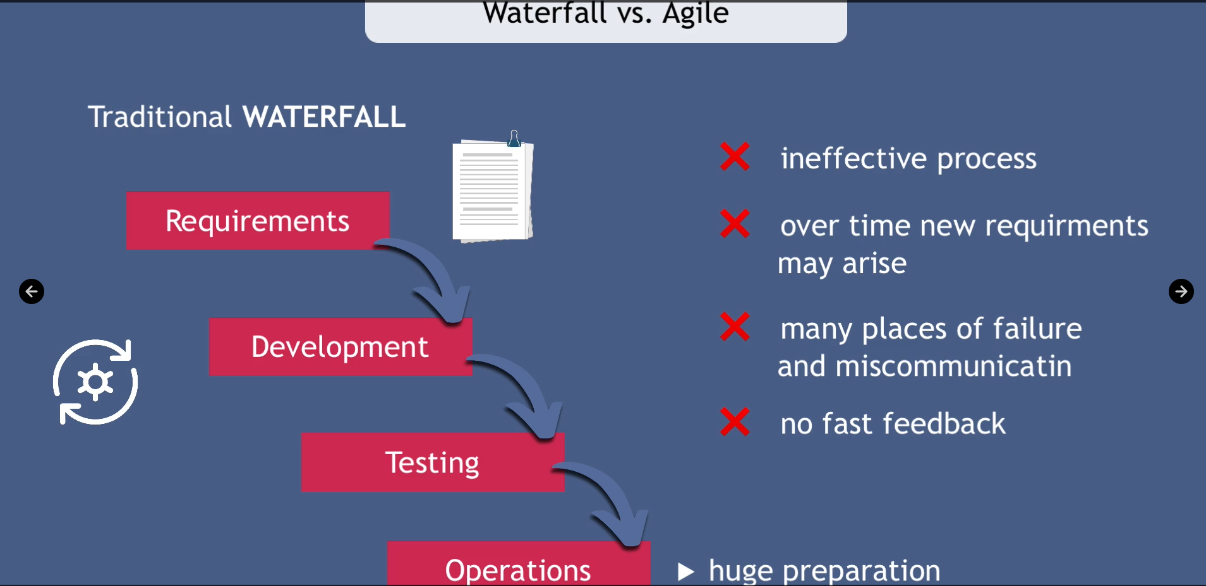

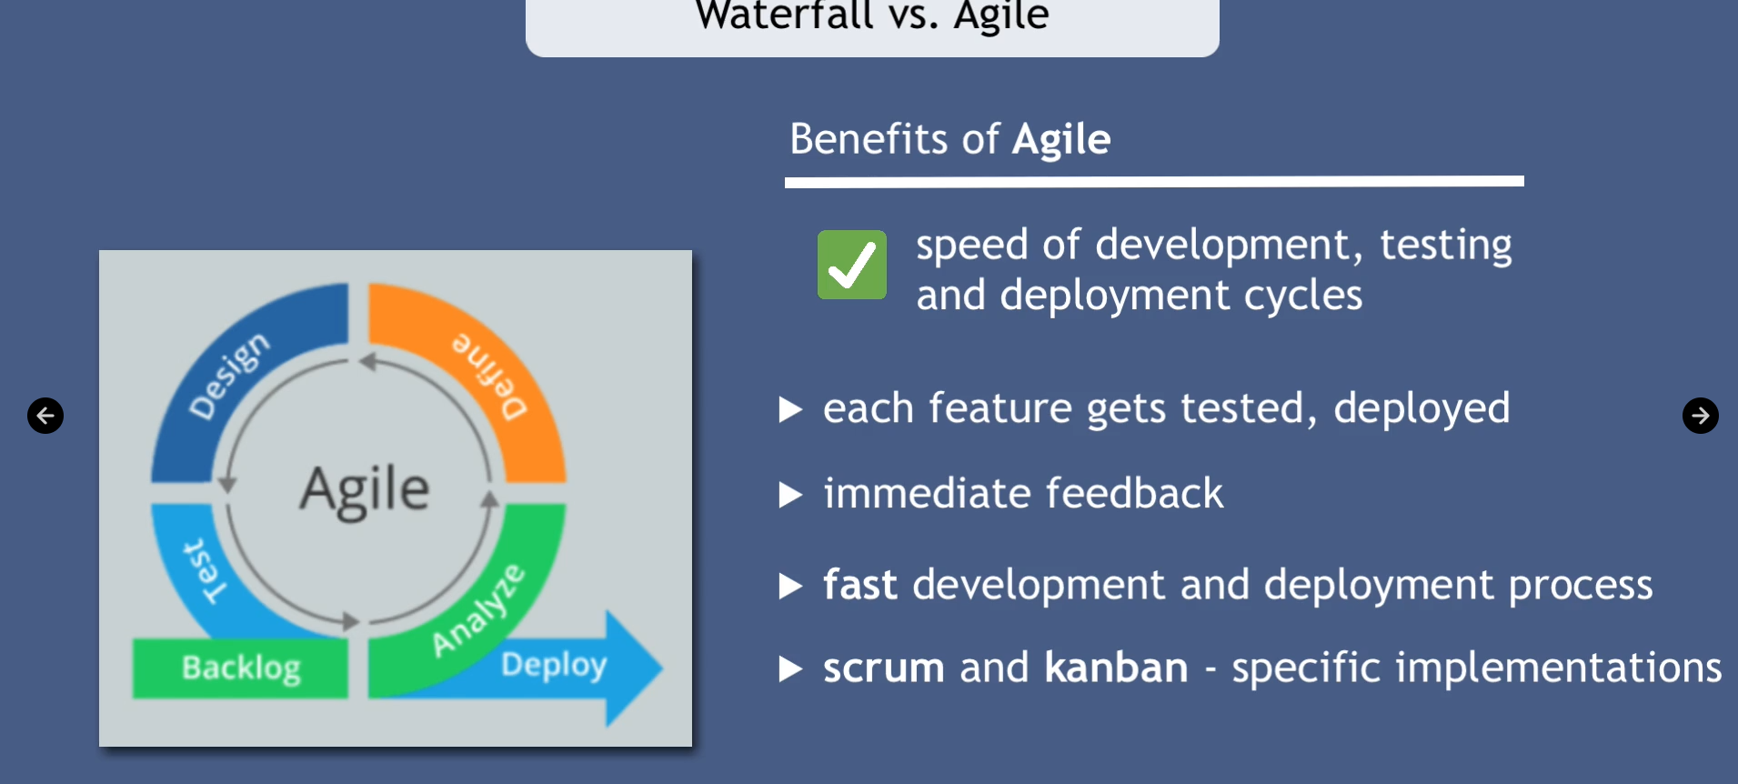

**Operating system**

The system will contain all hardware parts like cpu and memory and storage and i/o devices .

The application can not communication with hardware then os will act in b/w to help them to communicate